Tugas 2

Pengenalan GIT



Muhamad Naufal Burhanuddin Balit Full Stack 02

1. Screen shoot hasil website

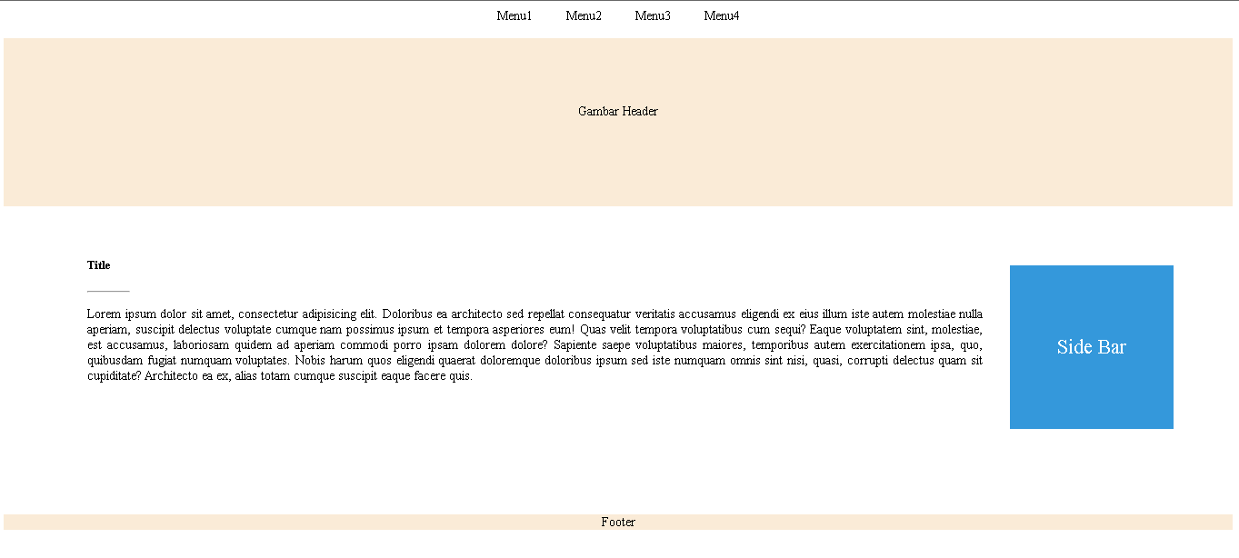

2. Link Github